Instructions for Use - Carriers
- LOGIN
In order to log into the eTaxes system you need a username and a password. Enter them into boxes provided and click ‘Login’.
Have you forgotten your username/ password? At this link you will find instructions on how to proceed in case you have forgotten your username and/ or password.
Figure 1: Login form

- SELECTING THE TAXABLE PERSON
After successfully logging in with your username and your password, you have come to the page where you are asked to select a taxable person, you would like to represent.
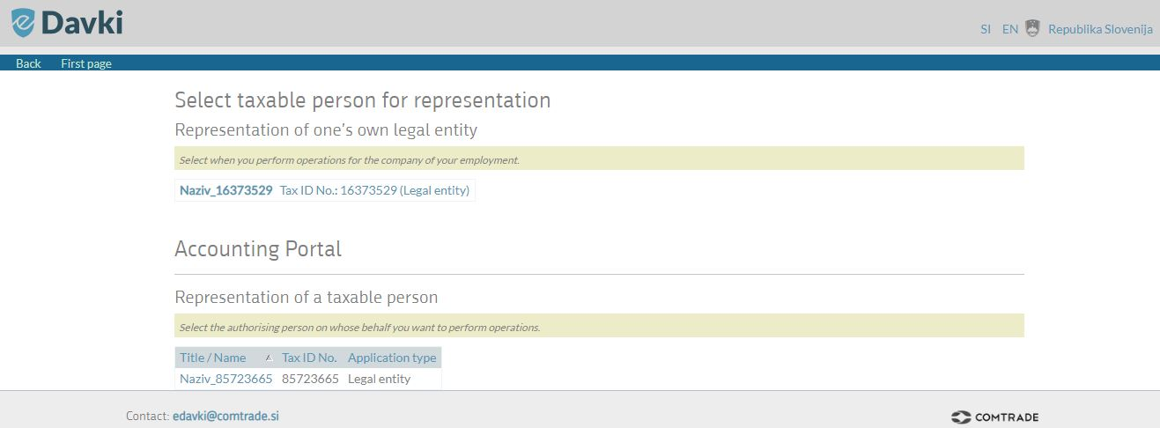
Figure 2: Selecting the taxable person
If you would like to conduct activities on behalf of your own legal entity, please select a link in the 'Representation of one's own legal entity' column.
If you would like to conduct activities on behalf of another taxable person (as a representative), please select the appropriate link in the 'Representation of a taxable person' column by clicking on the name/ title of the taxable person you represent.

- CONTROL PANEL
After selecting the taxable person you would like to represent, you have come to Control panel, where the list of recent transport reports is displayed. Recent transport reports are sorted descending by edit date.

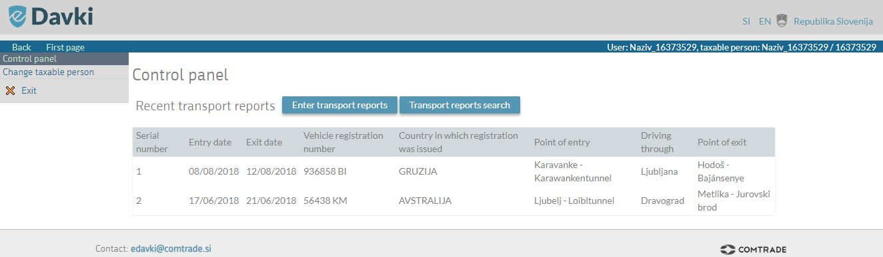
Figure 3: Control panel
By using the menu on the left–hand side you may return to the Control panel, you may select another taxable person by clicking on Change of a taxable person, ask for Help, or you may choose to exit the portal by clicking on Exit.
By clicking on 'Enter transport reports' you will be directed to the page, where you can enter new transport reports.
By clicking on 'Transport reports search' you will be directed to the page, where you can search for previously entered transport reports and edit them.

- CHANGE OF A TAXABLE PERSON
If you would like to conduct activities on behalf of another taxable person, select the 'Change of a taxable person' link in the left-side menu. In the right upper corner (blue ribbon) your name/ title and the name/ title of the taxable peson, on whose behalf you are conducting activities are displayed all the time.

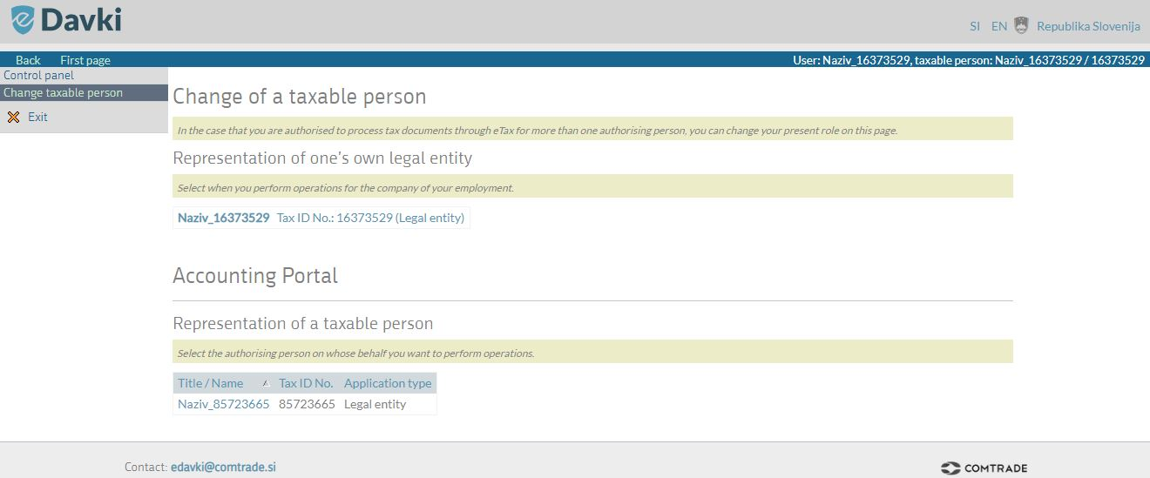
Figure 4: Change taxable person

- ENTERING TRANSPORT REPORTS
Return to the 'Control panel' page by clicking the link in the left-hand side menu. Then select the 'Enter transport reports' link to continue.

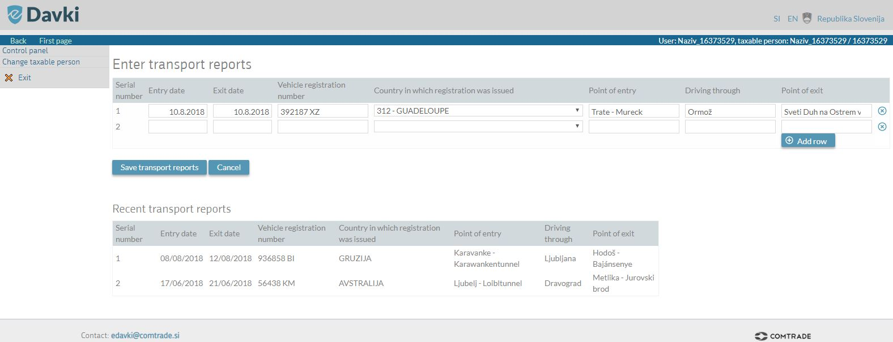
Figure 5: Entering transport reports
Transport reports may be edited up to 1 day prior to the entry date into the country!
To enter new transport report fill in the following fields (all fields are required):
- Date of entry into the country
- Date of exit from the country
- Vehicle registration number (the dropdown menu allows you to choose registration numbers that have been entered in the current year)
- Country, in which the registration was issued (the dropdown menu allows you to choose from the list of countries)
- Point of entry into the country (the dropdown menu allows you to choose from the list of border crossings; you may also type in the name of the border crossing)
- Point of exit from the country (the dropdown menu allows you to choose from the list of border crossings; you may also type in the name of the border crossing).
New transport reports may be entered by clicking on 'Add row'.
After you have entered all planned transport reports, click 'Confirm' in order to save all the entries.
The 'Cancel' button deletes! all the transport reports that you have not saved by clicking on the 'Confirm' button.
The 'Recent transport reports' displays a list of all recently entered transport reports. They are sorted descending by edit date.

- HOW TO LOOK FOR SPECIFIC TRANSPORT REPORTS?
Return to the 'Control panel' page by clicking the link in the left-hand side menu. Then select the 'Transport reports search' link.

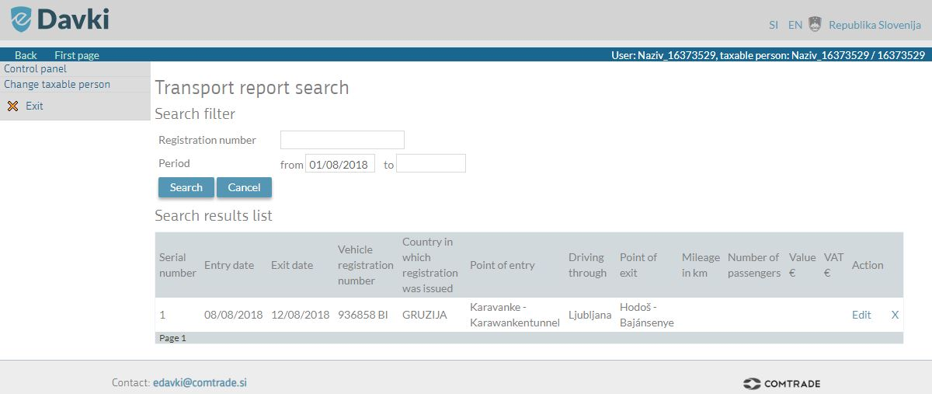
Figure 6: Look for specific transport reports
This function enables you to examine the entered transport reports, and also allows users to edit the reports.
You may look for specific transport reports by entering:
- The registration number – complete the field 'Registration number' with the registration number of the vehicle that performs the transport.
- Period – enter the search period 'from – to' by entering the date in the following format: day/month/year (DD/MM/YY).

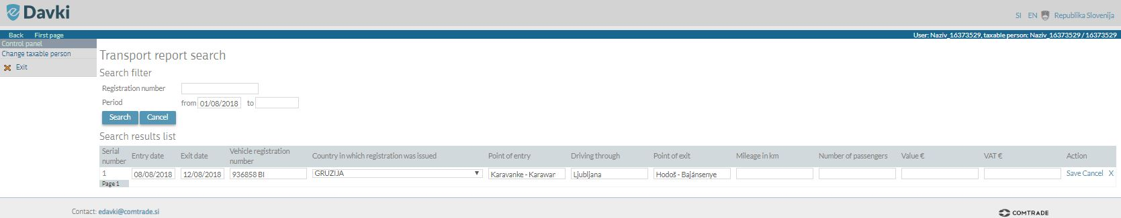
Figure 7: How to find specific transport reports
Each search result is at the end of the row provided with the links 'Edit' and 'X'.
By clicking on 'Edit' users are able to enter changes to the existent data.
By clicking on 'X' the entire row (transport report) will be deleted.
Save all changes by selecting the 'Save' button. The 'Cancel' button cancels all the entered changes.
IMPORTANT NOTICE! Up to 1 day prior to the entry date into the country you will be able to edit all data in your transport report. At later date you will only be able to edit the following fields: Milleage in km, Number of passengers, Value €, VAT €.

